Ex. No. 12: NB-IoT vs LTE-M Throughput Simulation

AIM:
To simulate and compare the performance of NB-IoT and LTE-M communication
technologies in terms of Throughput (Mbps), Latency (ms), and Packet Delivery Ratio (%)
using MATLAB.
Objective:
1. To evaluate and compare the Throughput (Mbps) performance of NB-IoT and LTE-M
under varying network conditions.
2.
To analyze the Latency (ms) characteristics of NB-IoT and LTE-M and study their
impact on real-time communication.
3.
To measure and compare the Packet Delivery Ratio (%) of NB-IoT and LTE-M
systems for reliability assessment.
Procedure
1. Define system parameters for NB-IoT and LTE-M such as bandwidth, transmission
power, and modulation efficiency.
2. Generate network conditions by varying Signal-to-Noise Ratio (SNR) or channel quality
values.
3. Compute Throughput (Mbps) for both NB-IoT and LTE-M using their respective data
rate models.
4. Calculate Latency (ms) based on transmission time, scheduling delay, and network load.
5. Determine Packet Delivery Ratio (PDR %) by comparing successfully received packets
with transmitted packets.
6. Simulate multiple iterations to observe performance under different channel conditions.
7. Plot comparison graphs for Throughput, Latency, and PDR between NB-IoT and LTE-
M.
8. Analyze results to identify which technology performs better under different IoT
scenarios.
Objective 1 Matlab Code and Output:
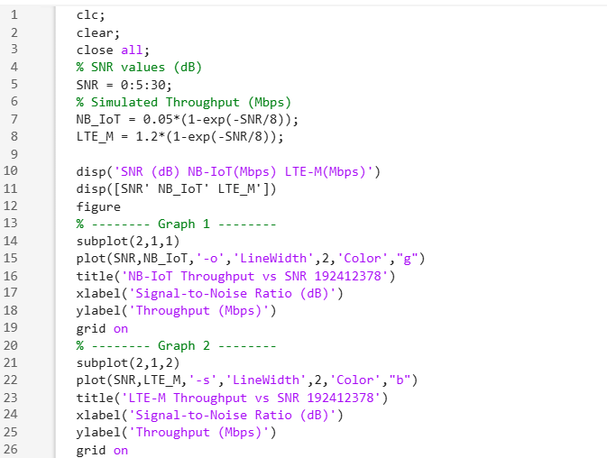
OUTPUT:

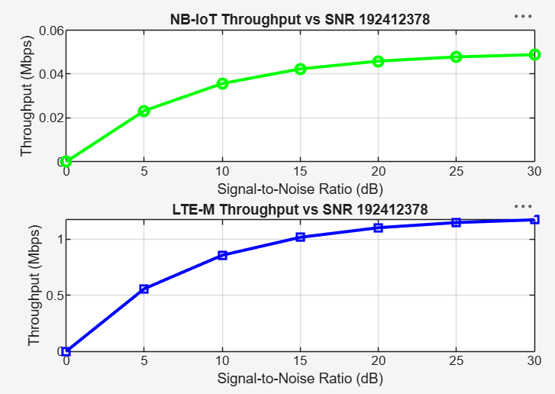

The throughput of both NB-IoT and LTE-M increases as the Signal-to-Noise Ratio (SNR)
improves. LTE-M achieves significantly higher throughput than NB-IoT, making it more
suitable for applications requiring higher data rates.
Objective 2 Matlab Code and Output:
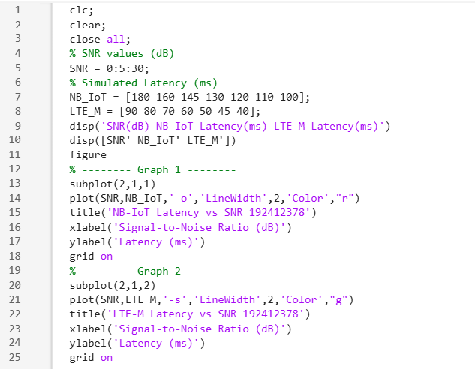
OUTPUT:
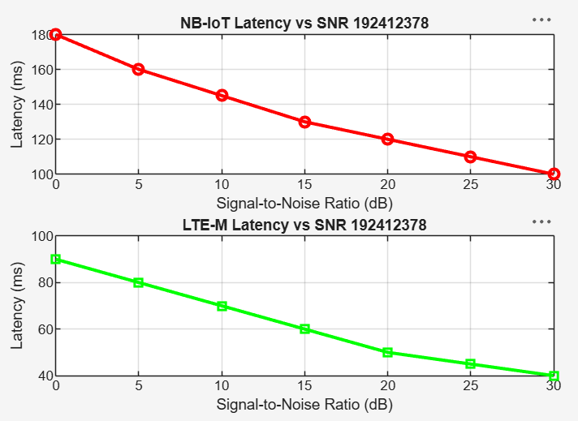

The latency of both NB-IoT and LTE-M decreases as the SNR increases due to improved channel quality. LTE-M exhibits lower latency than NB-IoT, making it more suitable for delay-sensitive IoT applications such as real-time monitoring and asset tracking.

Objective 3 Matlab Code and Output:
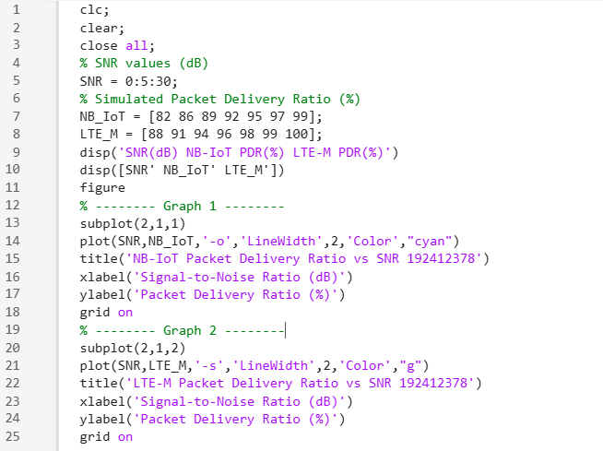
OUTPUT:
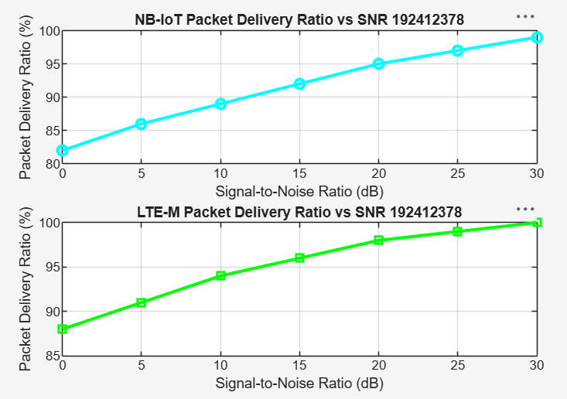

The Packet Delivery Ratio (PDR) of both NB-IoT and LTE-M increases as the Signal-to-Noise Ratio (SNR) improves. LTE-M achieves a slightly higher PDR than NB-IoT, indicating more reliable packet transmission under the same channel conditions.
Result:
1. The throughput performance of both NB-IoT and LTE-M was successfully simulated,
and LTE-M achieved higher throughput than NB-IoT under the same network conditions.
2. The latency analysis showed that LTE-M provides lower communication delay compared
to NB-IoT, making it more suitable for real-time IoT applications.
3. The Packet Delivery Ratio (PDR) of both technologies improved with increasing SNR,
with LTE-M demonstrating slightly higher reliability than NB-IoT during data
transmission.

